Boolean Blind SQL Injection
Proof of Concept Report — HackViser Lab
Prepared by: Aakash Singh | Date: May 31, 2026

Vulnerability Information

Author | Aakash Singh
Date | May 31, 2026
Lab | Boolean Blind SQL Injection
Platform | HackViser
Vulnerability Type | Boolean-Based Blind SQL Injection
Severity | Critical
CWE | CWE-89
Impact
An attacker can infer sensitive database content by sending boolean-based blind SQL payloads. Combined with cluster bomb attacks and CONCAT payloads, this enables stock manipulation and data enumeration without direct output.
Reproduction Steps
Step 1: Identify the vulnerable product stock-check endpoint using Burp Suite HTTP history.
Step 2: Launch a Cluster Bomb attack with two payload positions — position 1 (product ID) and position 2 (stock value at offset 97).
Step 3: Use a boolean blind query to manipulate stock: inject a CONCAT payload at the 5th position to handle special characters.
Step 4: Change the stock value condition from 100 to 150 to mark items as 'out of stock'.
Step 5: Collage payloads for the 2nd injection position to confirm boolean logic works.
Step 6: Collage at the 5th position with special characters to bypass filters.
Step 7: Confirm payload 1 works with cluster bomb — 5th position identifies special char offset.
Step 8: Review attack output; 5th position result missing confirms special character handling.
Step 9: Confirm product now shows as 'in stock' after boolean manipulation.
Step 10: Capture request for iPhone 11 product.
Step 11: Re-test both conditions (true/false) in Burp Repeater to validate the injection.
Step 12: Lab completed — Boolean Blind SQL Injection successfully demonstrated.
Evidence Screenshots
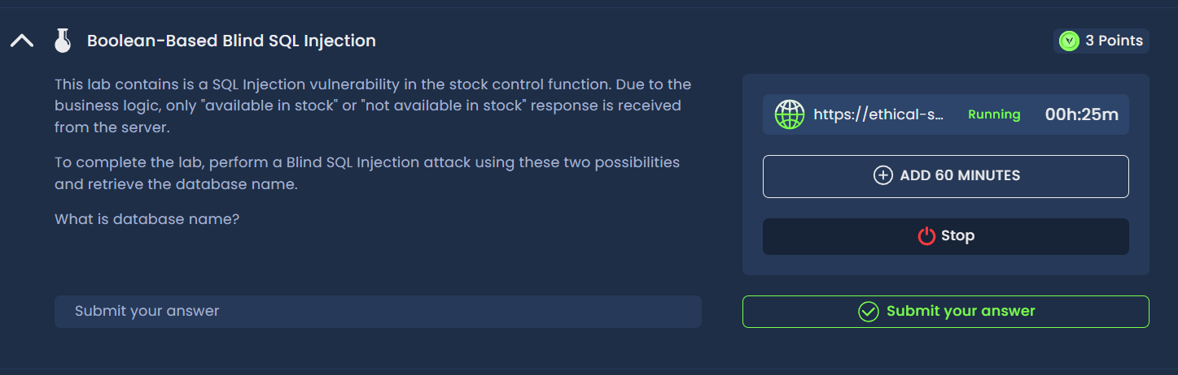
Figure 1: Initial Burp capture — identifying injection point
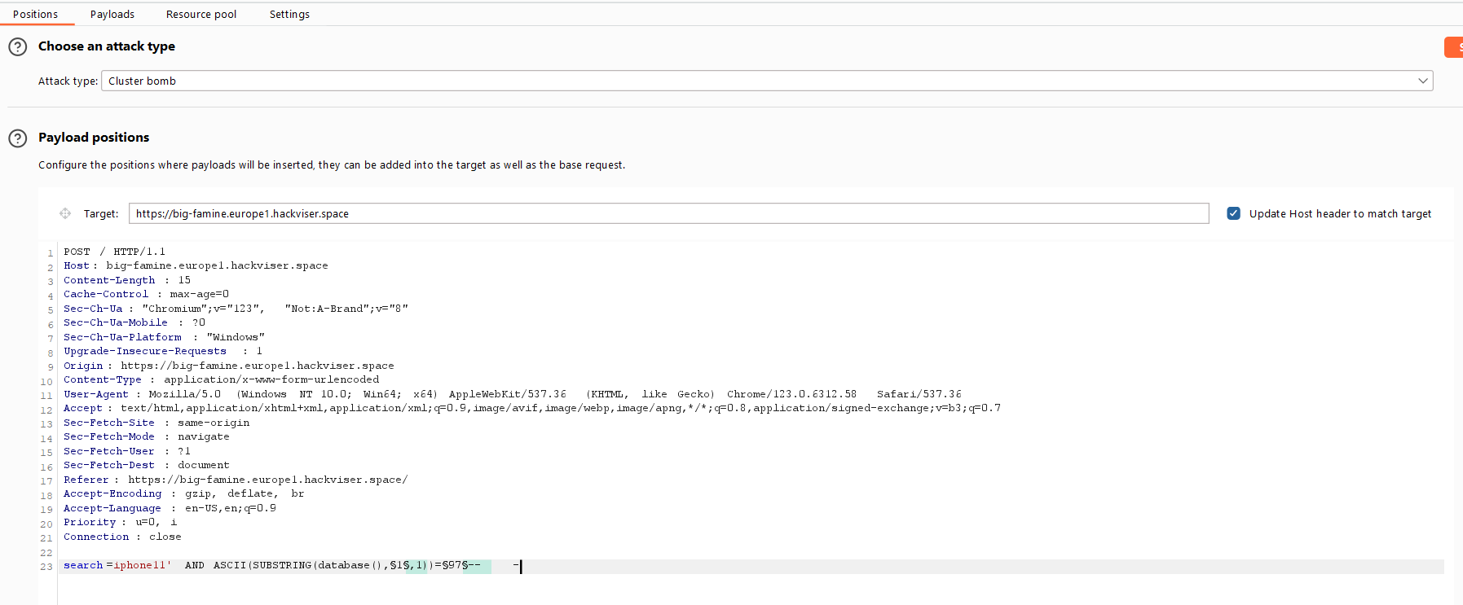
Figure 2: Cluster Bomb attack setup — two payload positions
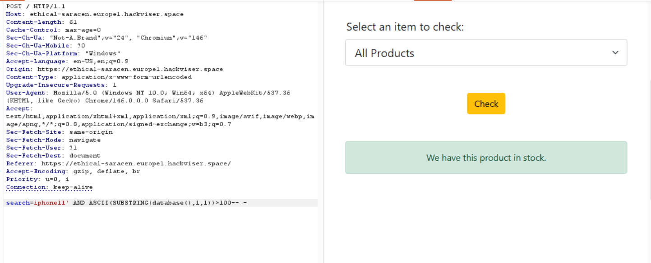
Figure 3: Boolean blind query — stock manipulation
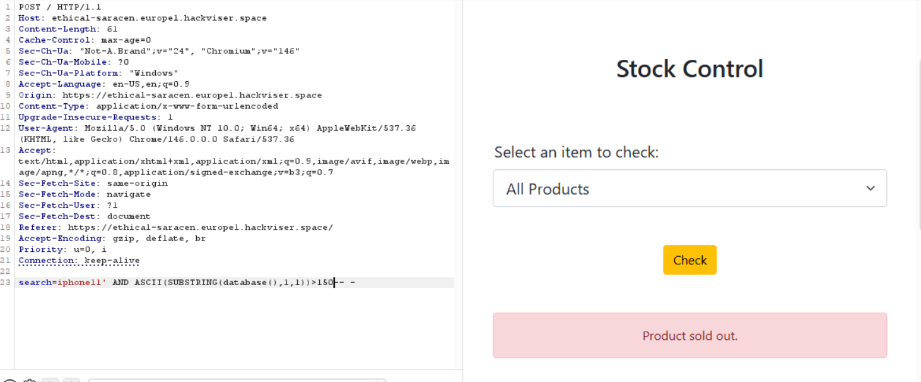
Figure 4: Value changed from 100 to 150 — out of stock
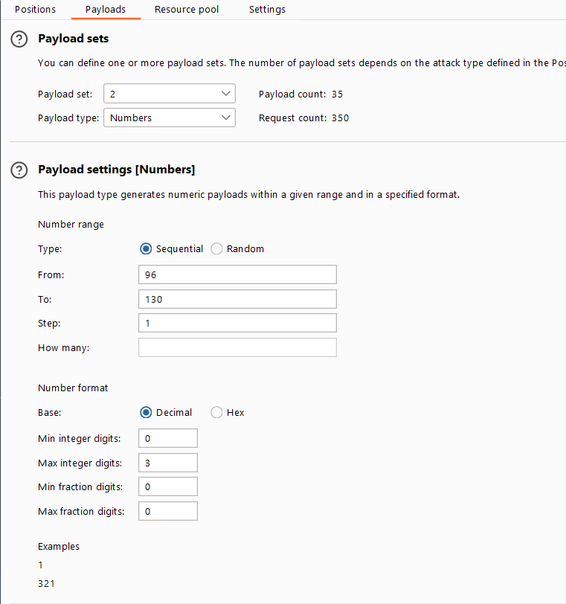
Figure 5: Collage payload 2nd position
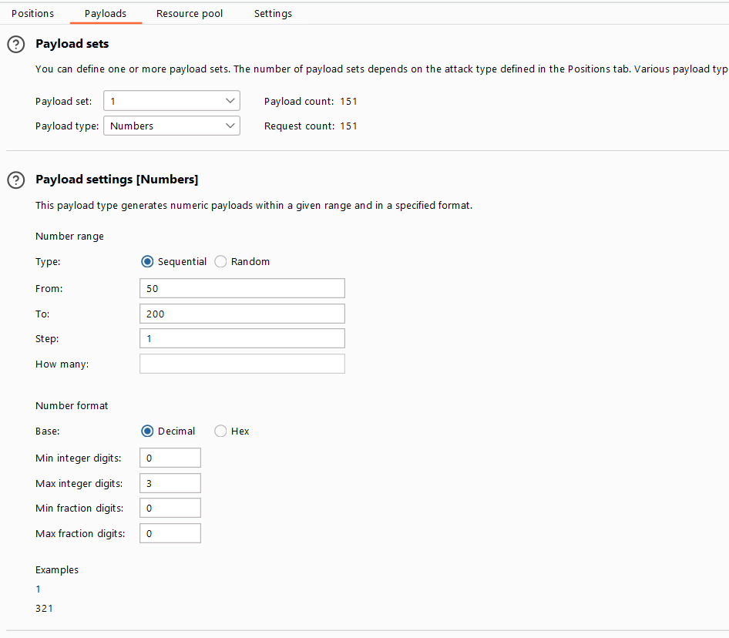
Figure 6: 5th position — special character injection
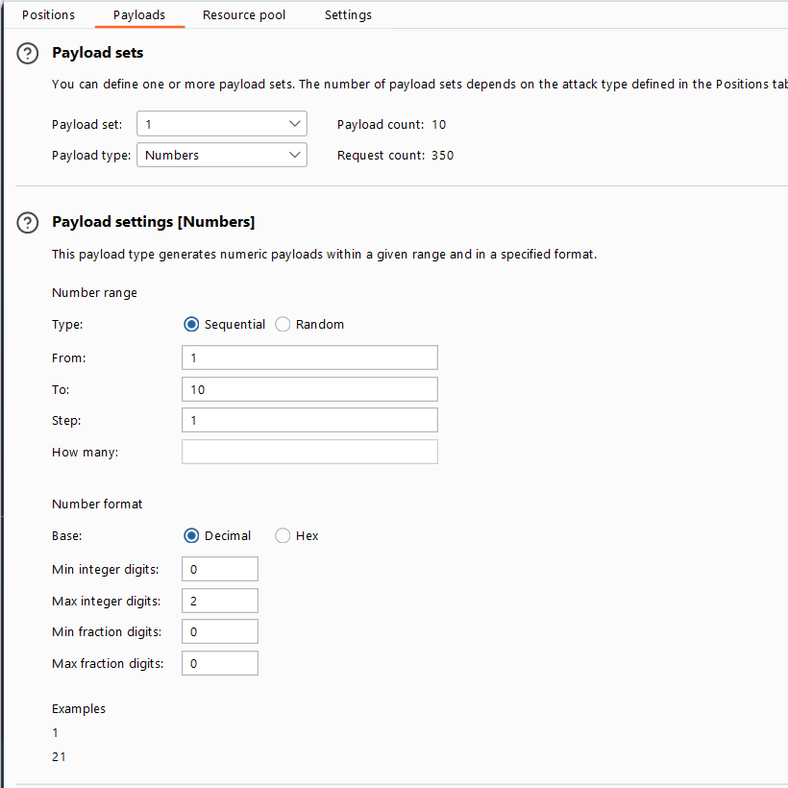
Figure 7: Payload 1 cluster bomb — collage
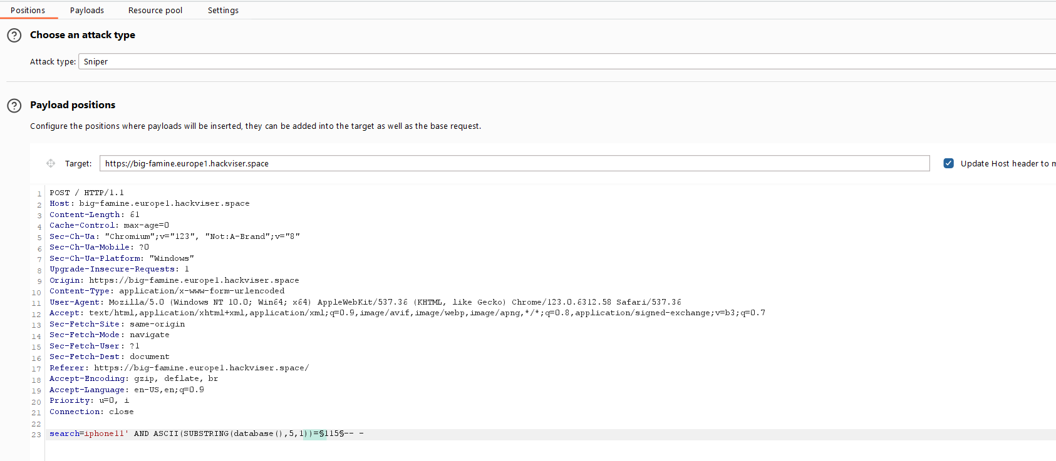
Figure 8: Cluster bomb output — 5th position missing (special char)
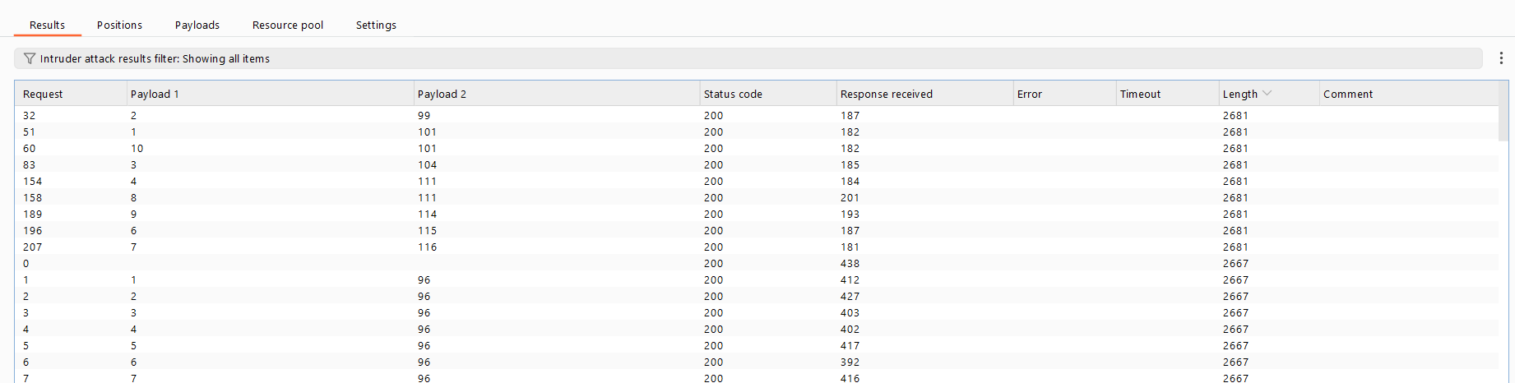
Figure 9: Product showing in stock post-manipulation
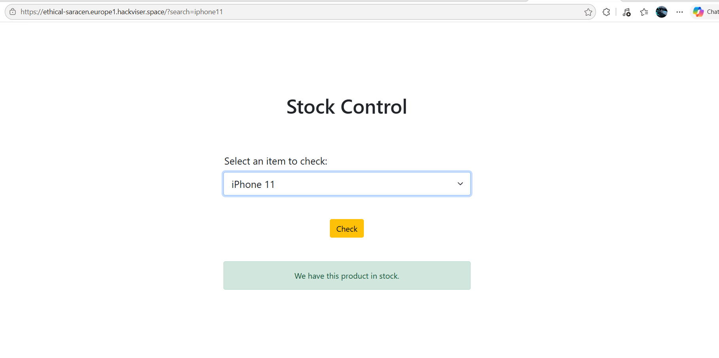
Figure 10: iPhone 11 request captured
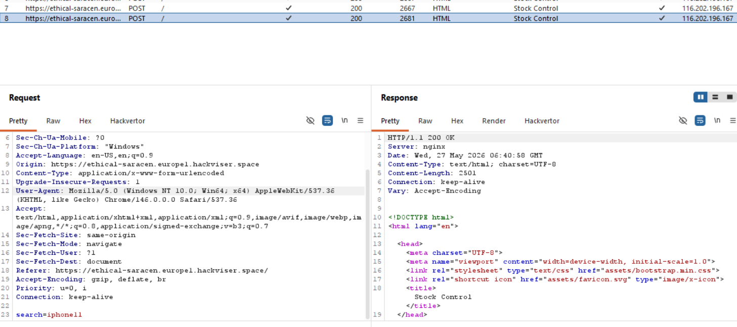
Figure 11: Both true/false conditions tested in Repeater
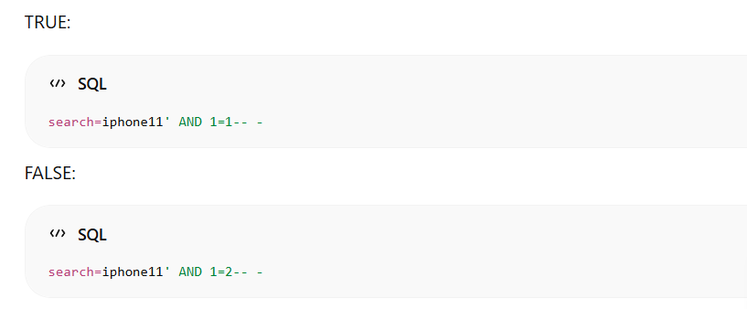
Figure 12: Lab solved confirmation
Remediation
Parameterize all SQL queries. Validate and sanitize inputs including numeric values. Implement WAF rules to detect and block SQL injection patterns.
Confidential — Prepared by Aakash Singh | Security Research POC

